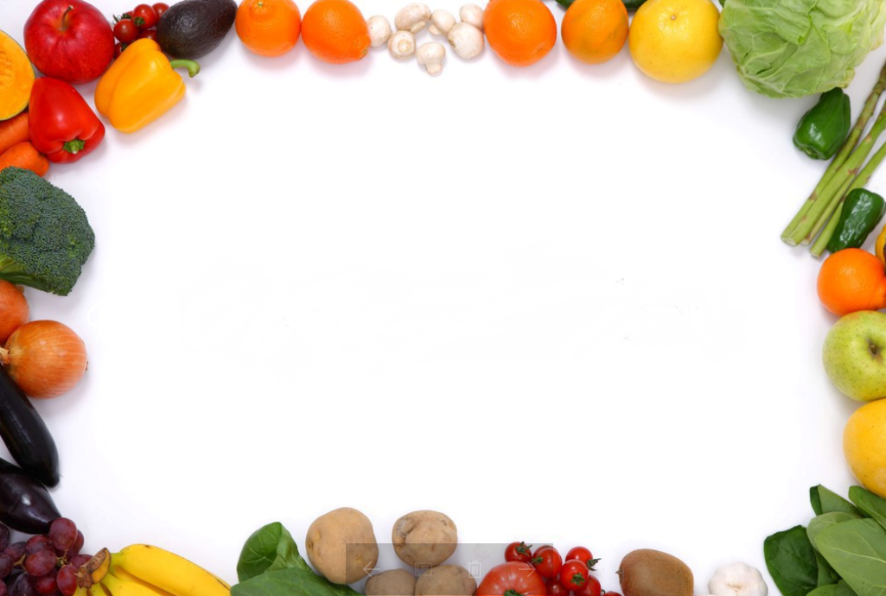 | SABAH KAHVALTISI/BREAKFAST | ÖĞLE YEMEĞİ/LUNCH | İKİNDİ KAHVALTISI/AFTERNOON SNACKS
01.03.2017  ÇRŞ/WED. | HAŞLANMIŞ YUMURTA, SERPME KAHVALTI (peynir, zeytin, tahin-pekmez, bal ), BİTKİ ÇAYI/ BOILED EGGS, STANDARD BREAKFAST(cheese, olive, molasses with tahini, honey) HERBALTEA | ETLİ BARBUNYA, BULGUR PİLAVI, CACIK/ CRANBERRY BEANS WITH MEAT, RICE OF WHEAT GRAINS, CUCUMBER YOGURT | ISLAK KURABİYE, MEYVE/ WET COOKIES, FRUIT
02.03.2017  PRŞ/THUR. | PATATESLİ YUMURTA,SERPME KAHVALTI (peynir, zeytin, tahin-pekmez, bal,) BİTKİ ÇAYI/ POTATO EGGS, STANDARD BREAKFAST, HERBAL TEA | ETLİ DÜĞÜN ÇORBASI, FIRNDA KARNABAHAR, PİRİNÇ PİLAV, HAVUÇ SALATASI/ SOUP, BAKED CAULI, RICE, CARROT SALAD | PİŞİ, AYRAN/ HOME-MADE PUFF PASTRY, AYRAN
03.03.2017  CUMA/FRID. | KIZARMIŞ EKMEK, SÜTLÜ YUMARTA, SERPME KAHVALTI (peynir, zeytin, tahin-pekmez, bal), SÜT/ TOASTED BREAD, EGG, STANDARD BREAKFAST, MILK | KURU FASULYE, PİRİNÇ PİLAVI, SALATA/ DRIED BEANS, RICE, SALAD | MİNİ POĞAÇA, AYRAN/ HOME-MADE PASTRY, AYRAN
06.03.2017  PZTS/MON | TOST,SAHANDA YUMURTA, SERPME KAHVALTI (peynir, zeytin, tahin-pekmez, bal) SÜT/ TOAST, EGG, STANDARD BREAKFAST, MILK | YOĞURT ÇORBA, GARNİTÜRLÜ HİNDİ, ŞEHRİYE PİLAVI, SALATA/ SOUP, TURKEY, RICE, SALAD | KANEPE, MEYVE/ CANEPE, FRUİT
07.03.2017  SALI/TUE. | KIYMALI YUMURTA, SERPME KAHVALTI (peynir, zeytin, tahin-pekmez, bal) SÜT/ MINCED MEAT EGG, STANDARD BREAKFAST, MILK | HAVUÇ ÇORBA, MANTI, SALATA/ SOUP, STEAMED DUMPLING, SALAD | ISLAK KEK, MEYVE TABAĞI/ BROWNIE, FUİT
08.03.2017  ÇRŞ/WED. | OMLET , SERPME KAHVALTI (peynir, zeytin, tahin-pekmez, bal) SÜT/ OMELETTE, STANDARD BREAKFAST, MILK | KIRMIZI MERCİMEK ÇORBA, ETLİ-ISPANAKLI KOL BÖREĞİ, AYRAN/ SOUP, ROLLED PASTRY WITH MEAT AND SPINACH, AYRAN | SÜTLAÇ/ RICE PUDDING
09.03.2017  PRŞ/THUR. | HAŞLANMIŞ YUMURTA, SERPME KAHVALTI (peynir, zeytin, tahin-pekmez ,bal ) BİTKİ ÇAYI/ BOILED EGGS, STANDARD BREAKFAST, HERBAL TEA | EZOGELİN ÇORBA, KIYMALI KABAK YEMEĞİ, MAKARNA ,AYRAN/ SOUP, ZUCCHINI WITH MEAT, PASTA, AYRAN | SUSAMLI HALKA, ELMA/SESAME RINGS, FRUİT
10.03.2017  CUMA/FRID. | FIRINDA KAŞARLI EKMEK, SERPME KAHVALTI (peynir, zeytin, tahin-pekmez, bal) SÜT/ BAKED BREAD WITH CHEESE, STANDARD BREAKFAST, MILK | ETLİ NOHUT, PİRİNÇ PİLAVI, CACIK/ CHICKPEAS WITH MEAT, RICE, CUCUMBER YOGURT | SAKIZLI MUHALLEBİ, MEYVE/ MASTIC-GUM PUDDING, FRUIT
13.03.2017  PZTS/ MON. | SİMİT , SERPME KAHVALTI (peynir, zeytin, tahin-pekmez, bal) SÜT/ SIMIT, STANDARD BREAKFAST, MILK | EKŞİLİ KÖFTE, FIRINDA BEŞAMEL SOSLU MAKARNA, CACIK/ MEATBALLS WITH RICE IN EGG AND LEMON SAUCE, BAKED PASTA WITH BECHAMEL SAUCE, CUCUMBER TOGURT | TAHİNLİ KURABİYE/ TAHINA COOKIES
14.03.2017  SALI/TUE. | TOST, SERPME KAHVALTI (peynir, zeytin, tahin-pekmez, bal) SÜT/ TOAST, STANDARD BREAKFAST, MILK | MERCİMEKLİ ERİŞTE, KADINBUDU KÖFTE,PÜRE, HAVUÇ SALATASI/ NOODLE WTIH LENTIL, MEAT, POTATO PUREE, CARROT SALAD | YAŞ PASTA, MEYVE/ CAKE, FRUIT
15.03.2017  ÇRŞ/WED. | FIRINDA EKMEK KIZARTMASI, SERPME KAHVALTI (peynir, zeytin, tahin-pekmez, bal) SÜT/ BAKED BREAD, STANDARD BREAKFAST, MILK | KIYMALI TARHANA ÇORBASI, KARNABAHAR TOPLARI, ŞEHRİYE PİLAV, SALATA/ SOUP, CAULI BALLS, RICE, SALAD | ÜZÜMLÜ KURABİYE, MEYVE/ COOKIE WITH GRAPES, FRUIT
16.03.2017  PRŞ/THUR. | MANTARLI YUMURTA, SERPME KAHVALTI (peynir, zeytin, tahin-pekmez, bal) SÜT/ MUSHROOM EGG, STANDARD BREAKFAST, MILK | ETLİ NOHUT, PİRİNÇ PİLAVI, SALATA/ CHICKPEAS WITH MEAT, RICE, SALAD | SUSAMLI HALKA, MEYVE/ SESAME RINGS, FRUIT
17.03.2017  CUMA/FRID. | TOST , SERPME KAHVALTI (peynir, zeytin, tahin-pekmez, bal,) IHLAMUR/ TOAST, STANDARD BREAKFAST, LINDEN TEA | SEBZE TÜRLÜ, KIYMALI MERCİMEK YEMEĞİ, ERİŞTE MAKARNA, SALATA/ VEGETABLE MEAL, LENTIL WITH MEAT, NOODLE, SALAD | MİLFÖY BÖREĞİ, MEYVE/ PUFF PASTRY, FRUIT
20.03.2017  PZTS/MON. | HAŞLANMIŞ YUMURTA, SERPME KAHVALTI (peynir, zeytin, tahin-pekmez, bal) SÜT/ BOILED EGGS, STANDARD BREAKFAST, MILK | TARHANA ÇORBA, KABAK DOLMA, YOĞURT/ SOUP, STUFFED ZUCCHINI, YOGURT | SİGARA BÖREĞİ, POTAKAL SUYU/ SPRING ROLLS, ORANGE JUICE
21.03.2017  SALI/TUE. | SİMİT, SERPME KAHVALTI (peynir, zeytin, tahin-pekmez, bal) SÜT/ SIMIT, STANDARD BREAKFAST, MILK | KREMALI MANTAR ÇORBA, FIRINDA PATATES OTURTMA, ŞEHRİYELİ PİLAV, YOĞURT/ SOUP, BAKED POTATO WITH MEAT, RICE, YOGURT | KURABİYE, MEYVE/ COOKIES, FRUIT
22.03.2017  ÇRŞ/WED. | FIRINDA KAŞARLI EKMEK, SERPME KAHVALTI (peynir, zeytin, tahin-pekmez, bal) BİTKİ ÇAYI/ BAKED BREAD WITH CHEESE, STANDARD BREAKFAST, HERBAL TEA | TARHANA ÇORBA, EV USULÜ KIYMALI PİDE, AYRAN/ SOUP, ROUND AND FLAT BREAD WITH MEAT, AYRAN | ELMALI TURTA/ APPLE PIE
23.03.2017  PRŞ/THUR. | KREP, SERPME KAHVALTI (peynir, zeytin, tahin-pekmez, bal,), SÜT/ PANCAKE, STANDARD BREAKFAST, MILK | YEŞİL MERCİMEKLİ UN ÇORBA, ETLİ LAHANA SARMA, YOGURT/ SOUP, STUFFED CABBAGE WITH MEAT, YOGURT | SİMİT, MEYVE/ SIMIT, FRUIT
24.03.2017  CUMA/FRID. | MANTARLI OMLET, SERPME KAHVALTI (peynir, zeytin, tahin-pekmez, bal,) SÜT/ MUSHROOM EGG, STANDARD BREAKFAST | DOMATES ÇORBA, PIRASA, GEZEN TAVUK SOTE/ SOUP, LEAK, FREE-RANGE CHICKEN | ISLAK KURABİYE/ WET COOKIE
27.03.2017  PZTS/MON. | SİMİT, SERPME KAHVALTI (peynir, zeytin, tahin-pekmez, bal) SÜT/ SIMIT, STANDARD BREAKFAST, MILK | EKŞİLİ KÖFTE, BEŞAMEL SOSLU MAKARNA/ MEAT BALL WITH LEMON SAUCE, PASTA WITH BECHAMEL SAUCE | TAHİNLİ KURABİYE, MEYVE/ TAHINA COOKIES, FRUIT
28.03.2017  SALI/TUE. | OMLET , SERPME KAHVALTI (peynir, zeytin, tahin-pekmez, bal,) SÜT/ OMELETTE, STANDARD BREAKFAST, MILK | TARHANA ÇORBA, PİZZA, AYRAN/ SOUP, PIZZA, AYRAN | MERCİMEK KÖFTE, KOMPOSTO SUYU/ LENTIL BALLS, COMPOTE JUICE
29.03.2017  ÇRŞ/WED. | TOST, SERPME KAHVALTI (peynir, zeytin, tahin-pekmez, bal,) SÜT/ TOAST, STANDARD BREAKFAST, MILK | KIRMIZI MERCİMEK ÇORBA,BİBER DOLMA ,SALATA, YOĞURT/ SOUP, STUFFED GREEN PEPPER, SALAD, YOGURT | KISIR , BİTKİ ÇAYI/ BURGHUL SALAD, HERBAL TEA
30.03.2017  PRŞ/THUR. | KREP, SERPME KAHVALTI (peynir, zeytin, tahin-pekmez, bal,) SÜT/ PANCAKE, STANDARD BREAKFAST, MILK | KURU FASULYE, PİRİNÇ PİLAVI, AYRAN, SALATA/ DRIED BEANS, RICE, AYRAN, SALAD | PİŞİ, AYRAN/ HOME-MADE PUFF PASTRY, AYRAN
31.03.2017  CUMA/FRID. | KIZARMIŞ EKMEK, SERPME KAHVALTI (peynir, zeytin, tahin-pekmez, bal,) SÜT/ BAKED BREAD, STANDARD BREAKFAST, MILK | YAYLA ÇORBA, DALYAN KÖFTE. BULGUR PİLAVI, MEVSİM SALATA/ SOUP, MEAT BALLS, RICE OF WHEAT GRAINS, SALAD | KAKAOLU KEK, BİTKİ ÇAYI/ COCOA CAKE, HERBAL TEA

TAD PRESCHOOL MAVİŞEHİR MART AYI YEMEK LİSTESİ
TAD PRESCHOOL MARCH MONTHLY MENU

KULLANILAN MARKALAR/OUR SUPPLIERS: PINAR ET VE SÜT ÜRÜNLERİ/DAIRY PRODUCTS, BALPARMAK/HONNEY, KOR GEZEN TAVUK/FREE-RANGE CHICKEN,
ATATÜRK ORMAN ÇİFTLİĞİ/DAIRY PRODUCTS, DOĞAL ZEYTİNYAĞI/NATURAL OLIVE OIL
EMİNE ÖZTÜRK
TAD PRESCHOOL MAVİŞEHİR
KURULUŞ MÜDÜRÜ

